PROJECT DOCUMENTATION AND REPORT:

**LONG TERM INTERNSHIP ON SALESFORCE PROJECT TITLE : BUILD AN EVENT MANAGEMENT SYSTEM USING SALES FORCE –(DEVELOPER )**

**SALESFORCE OF A CANDIDATE WITH INTERNAL MARKS**

\FACULTY MENTOR : K ANJANEYULY

TEAM ID : LTVIP2023TMID08768

TEAM SIZE : 1

TEAM MEMBER **:** CHAPIREDDY VENKATA SUHASINI

**Build an Event Management System using Salesforce Using Sales force of a**

**Candidate with Internal Marks**

**Description :**

The project aim is to provide real-time knowledge for all the students who have basic knowledge of Salesforce and Looking for a real-time project. This project will also help to those professionals who are in cross -technology and wanted to switch to Salesforce with the help of this project they will gain knowledge and can include into their resume as well .

**Introduction :**

Event management is the process of creating and maintaining an event. This process spans from the very beginning of planning all the way to post-event strategizing.

At the start, an event manager makes planning decisions, such as the time, location, and theme of their event. During an event, event managers oversee the event live and make sure things run smoothly. After an event, event managers are tasked with reviewing event data, submitting KPI and ROI findings, and staying on the ball for any post-event offerings.

All different branches of planning go into event management, including various types of sourcing, designing, regulation checks, and on-site management. In event management, you could be in the process of creating a conference, a product launch, an internal sales kick-off, or even a wedding. Really, any event that requires considerable planning and execution is event management.

**Create a salesforce org** – We have created a developer org and activated the account.

Salesforce signup link : <https://developer.salesforce.com/signup>

Salesforce Login link : <https://login.salesforce.com>

In the below video we have logged into Salesforce org.

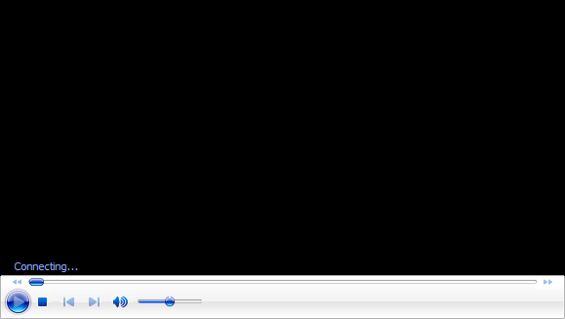

**Object:-**  
In your Salesforce org, click Setup and select Setup to open Setup.

1. Click the Object Manager tab. If you don’t see it, enter Object Manager in the Quick Find box.
2. On the Object Manager Object Manager page, click Create | Custom Object.  
   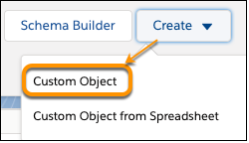
3. For Label, enter whatever you want to call your custom object. Notice that the Object Name and Record Name fields auto-fill.
4. For Plural Label, enter the plural form of your custom object name.
5. Check the box for Launch New Custom Tab Wizard after saving this custom object.
6. Leave the rest of the values as default and click Save.
7. On the New Custom Object Tab page, click the Tab Style field and select a style you like. The style sets the icon to display in the UI for the object.
8. Click Next, Next, and Save.

Tabs:-

Tabs in Salesforce help users view the information at a glance. It displays the data of objects and other web content in the application.

There are mainly 4 types of tabs:-

* Standard Object Tabs
* Custom Object Tabs
* Web Tabs
* Visualforce Tabs

### **Creation Of Occasion Tab :-**

1. Click on Home tab, enter Tabs in Quick Find and select Tabs.

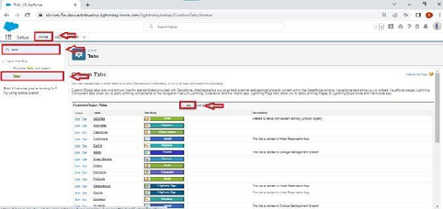

1. Under custom object tabs, click New :-

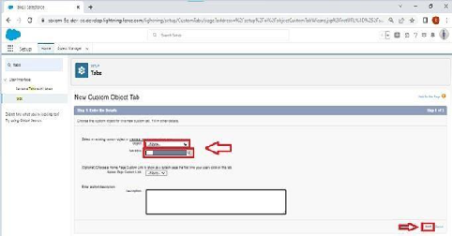

1. For Object, select Occasion.  
   4. For Tab Style, select any icon.  
   5. Leave all defaults as is. Click Next, Next, and Save.

### Creation Of Attendee Tab :-

1. Click on Home tab, enter Tabs in Quick Find and select Tabs.

2. Under custom object tabs, click New.

3. For Object, select Attendee.

4. For Tab Style, select any icon.

5. Leave all defaults as is. Click Next, Next, and Save.

### Creation Of Speakers Tab :-

1. Click on Home tab, enter Tabs in Quick Find and select Tabs.

2. Under custom object tabs, click New.

3. For Object, select Speaker.

4. For Tab Style, select any icon.

5. Leave all defaults as is. Click Next, Next, and Save.

### Creation Of Vendor Tab :-

1. Click on Home tab, enter Tabs in Quick Find and select Tabs.  
   2. Under custom object tabs, click New.  
   3. For Object, select Vendor.  
   4. For Tab Style, select any icon.  
   5. Leave all defaults as is. Click Next, Next, and Save.

### Creation Of Event Service Tab :-

1. Click on Home tab, enter Tabs in Quick Find and select Tabs.  
2.Undercustomobjecttabs,clickNew.  
3.ForObject,selectEventService.  
4.ForTabStyle,selectanyicon.  
5. Leave all defaults as is. Click Next, Next, and Save.

### Fields And Relationships :-

* Fields in Salesforce represents what the columns represent in relational databases. It can store data values which are required for a particular object in a record.

**There are 2 types of fields in salesforce:**

* Standard fields: There are four standard fields in every custom object that are Created By, Last Modified By, Owner, and the field created at the time of the creation of an object.
* These fields cannot be deleted or edited and they are always required. For standard objects, the fields which are present by default in them and cannot be deleted from standard objects are standard fields.
* Custom fields: The Custom fields which are added by the administrator/developer to meet the business requirements of any organization. They may or may not be required.

### Profile :-

* A profile is a group/collection of settings and permissions that define what a user can do in salesforce. A profile controls “Object permissions, Field permissions, User permissions, Tab settings, App settings, Apex class access, Visualforce page access, Page layouts, Record Types, Login hours & Login IP ranges.

* A profile can be assigned to many users, but user can be assigned single profile at a time.

### Creation On Profile :-

1. From Setup enter Profiles in the Quick Find box, and select Profiles.

2. From the list of profiles, find Standard User.

3. Click Clone.

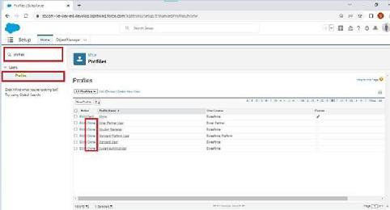

4. For Profile Name, enter Event user profile.

5. Click Save.

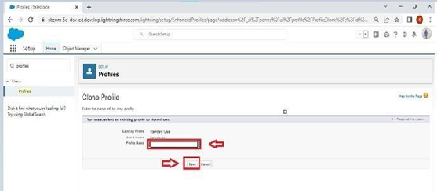

6. While still on the Event profile page, then click Edit.

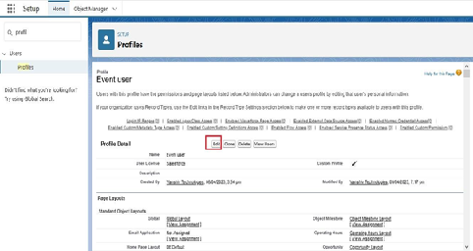

7. Scroll down to Custom Object Permissions and Give view all access permissions to the Attendees, speakers and vendors.

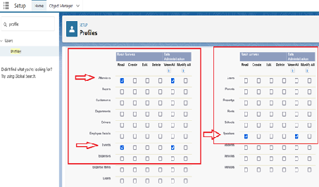

### Create A Profile With The Profile Name As “Event Vendors Profile” :-

1. From Setup enter Profiles in the Quick Find box, and select Profiles.

2. From the list of profiles, find Standard User.

3. Click Clone.

4. For Profile Name, enter Event vendors profile.

5. Click Save.

6. While still on the Event profile page, then click Edit.

7. Scroll down to Custom Object Permissions and Give view all access permissions to the Attendees, speakers and vendors.

### Create A Record (Occasion) :-

* Click on App Launcher on left side of screen.
* Search Event Management & click on it.
* Click on Occasion Tab.
* Click new and fill details & Save

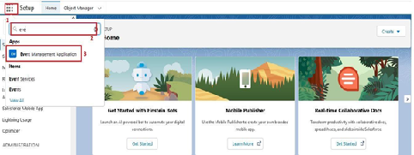

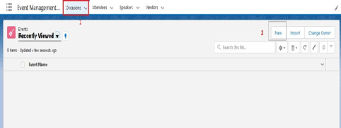

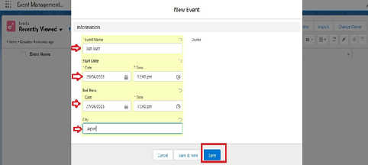

### Delete A Record(Occasion):-

* Click on App Launcher on left side of screen.
* Search Event Management & click on it.
* Click on Occasion Tab.
* Click on Arrow at right hand side on that Particular record.
* Click delete and delete again

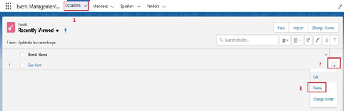

**Reports And Dashboards**

**Reports:-**

* 1. Click the App Launcher app launcher icon and select Space Station Construction.
  2. Click the Reports tab and click New Report.
  3. Click the Other Reports category.
  4. Select Space Station with Supplies and click Start Report. (If you don't see the Space Station with Supplies report type, go to Setup and click Object Manager. Next to Supply click the drop-down, then click Edit. Under Optional Features, check Allow Reports. Click Save. Then go back and create the report.)
  5. In the Add column search, search for Quantity, Unit Cost, and Total Cost fields and add them as columns. (You can also drag the fields from the Fields pane into the Columns section.)
  6. In the Add group search, enterSpace Station Name and select Space Station Name. This will separate the report by individual Space Station records.
  7. Click the Update Preview Automatically toggle to view column menus.
  8. Open the menu on the Quantity column and select Summarize, then deselect Sum.
  9. Open the menu on the Unit Cost column and select Summarize, then deselect Sum.
  10. Click Save & Run, enter Supplies for the Report Name and click Save.

**Dashboards:-**

1. Click the Dashboards tab.
2. Click New Dashboard.
3. Name the dashboard Construction and click Create.
4. Click +Component.
5. Search and select the Supplies report and click Select.
6. Select the Vertical Bar Chart component and click Add.
7. Click Save and then Done.

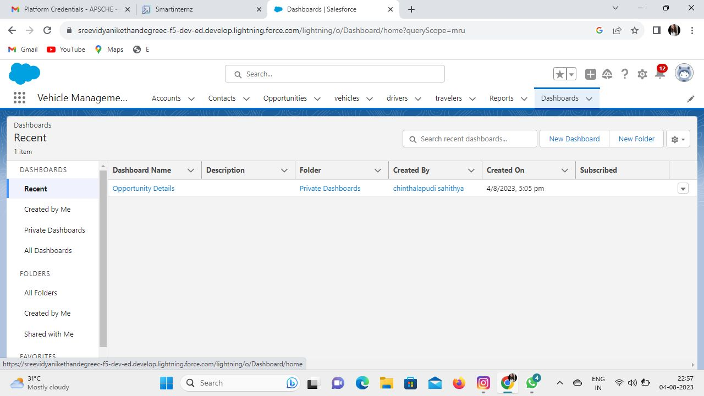

**Conclusion:-**

**Reporting:-**

Create and manage vehicle records to optimize the usage of your trucks and trailers that carry inventories to stores. To track the vehicles that carry goods out of a warehouse, assign them to that warehouse.